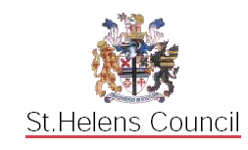

BEING THE

LOCAL EDUCATION AUTHORITY

INSTRUMENT OF GOVERNMENT: COMMUNITY PRIMARY

SCHOOL

1. The name of the school is Newton-le-Willows Primary School.

2. The school is a Community Primary School.

3. The name of the Governing Body is The Governing Body of Newton-le-Willows Primary School.

4. The Governing Body shall consist of:-

(a) 3 Parent Governors

(b) 1 LA Governor

(c) 1 Staff Governor

(d) the Head Teacher

(e) 8 Co-opted Governors

5. Total number of Governors : 14

(The Head Teacher to give written notice that s/he chooses not to be a Governor).

7. The term of office of all Governors is four years.

8. This Instrument of Government comes into effect on 14th December 2017.

9. This Instrument was made by order of the St. Helens Council Local Education Authority on 14th December 2017 to comply with Part 5 (Regulations 26-31) of the School Governance (Constitution) (England) Regulations 2012.

