Connecting your device to home Wi-Fi
- Connecting to home Wi-Fi 1. Once your laptop is turned on, you will be welcomed with a log on screen. In the bottom right corner, left click on the globe.
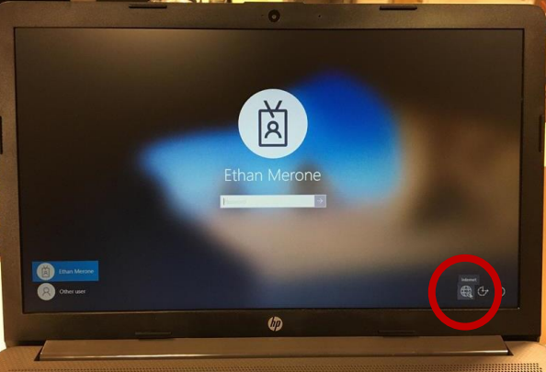
- This will bring up a list of networks, find your home network and left click on it. Once you left click on your network, left click on the connect button. 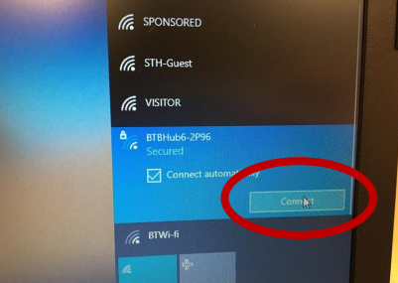
- 3. Type your home Wi-Fi password in and left click on next. 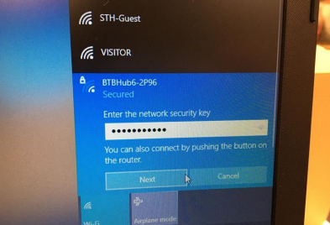
- After connecting to your network, you will now see a Wi-Fi symbol in the bottom right, this means you have connected to your home Wi-Fi. 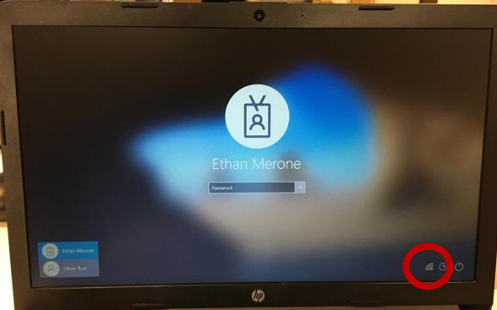

Signing Into Your Account
- Once you’ve turned your laptop on, you will be welcomed to a log-on screen, click “Other user” in the bottom left corner. 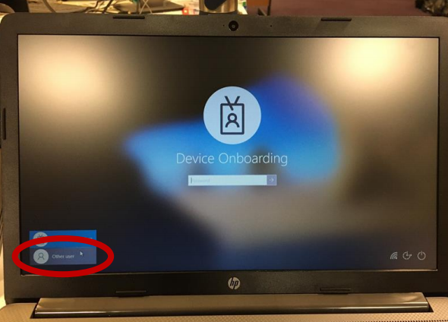
- Once you’ve clicked on other user, type your username in the “username” section, and your password in the “password” section.
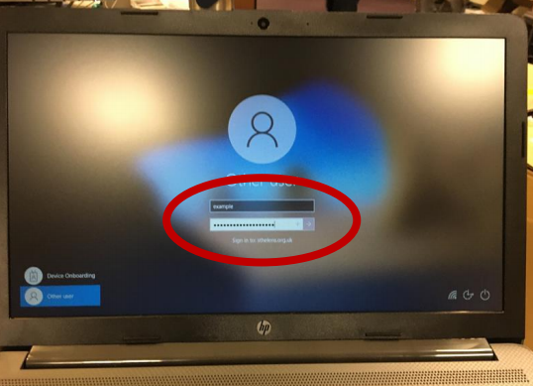
- Click on the arrow in the “password” section or press the ‘enter’ key. 