Newton-le-Willows Primary School

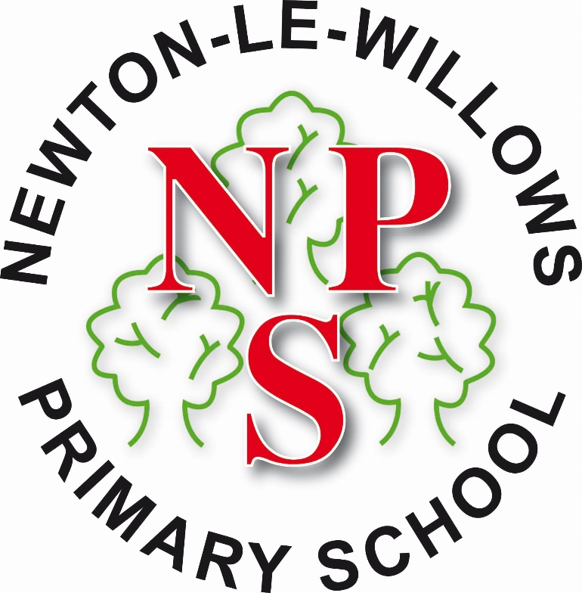

An Overview of Remote Learning

Remote Education Provision: Information For Parents
This information is intended to provide clarity and transparency to pupils and parents/carers about what to expect from remote education where national or local restrictions require entire cohorts (or bubbles) to remain at home.
For details of what to expect where individual pupils are self-isolating, please see the final section of this page.

The Remote Curriculum: What Is Taught To Pupils At Home
A pupil’s first day or two of being educated remotely might look different from our standard approach, while we take all necessary actions to prepare for a longer period of remote teaching.

What should my child expect from immediate remote education in the first day or two of pupils being sent home?
As a school, we offer a blended approach to remote education. This encompasses live lessons (‘face to face’ teaching), pre-recorded lessons (some of which are prepared and delivered by school staff and some of which are delivered via the Oak National Academy). In addition to this, we also use several online platforms such as Purple Mash, Times Tables Rockstars and Reading Plus.

Within the first day of being sent home, your child will be set online work by 9:00am. They will be able to find this work on both the school website and their virtual classroom on Microsoft Teams. Alongside this, you may also be set work on one of our online learning platforms - Purple Mash.

This work will relate to both your child’s current learning in line with their year group long term plans and will relate to units of work/learning which your child may have already been taught this year in order to reinforce learning.

Should a child have to work from home, they will also be provided with a virtual timetable to work alongside their online learning. This timetable will state when your child’s live lessons are scheduled for, as well as a suggested timetable for the rest of the week.

If your child is required to self-isolate, as a result of a school closure, your child will also be sent home with a pre-prepared, paper - based learning pack where possible, by the teacher the day before the child’s home learning period begins. This is to be used if your child experiences any difficulties connecting to the live lessons, learning materials or online learning platforms and will be able to be used, until school staff are able to resolve any technical difficulties for you.

For those pupils without access to online learning or for those pupils with Special Educational Needs who are working significantly below their peers, a paper – based learning pack will be provided for pupils on a weekly basis. These paper – based learning packs will be available to collect from school every Friday from 1.30pm and will need to be collected by the parent/carer. If the family are isolating, this pack/these packs should be collected from school by another family member. Paper-based packs will only be able to be delivered to families in exceptional circumstances.

All children were provided with a blank exercise book or pack of lined paper at the end of the Autumn term. Year 1 pupils who were self - isolating at the end of the Autumn term, have been given the opportunity to attend school to collect an exercise book if needed. Parents were asked both verbally by class teachers and via email to store this exercise book safely. This is to be used by children in the event of remote education to record their work. At the end of the home learning period, children should return this and all other written work to their class teacher.

When your child is close to completing an exercise book, parent/carers can contact school by phone or contact school via the relevant year group inbox by e mail, to arrange for another book to be made available for
collection from school.

Following the first few days of remote education, will my child be taught broadly the same curriculum as they would if they were in school?
We teach the same curriculum remotely as we do in school wherever possible and appropriate. However, we may need to make some adjustments in the types of resources on offer to your child, which may mean that lessons which are usually taught more practically will be supplemented with additional supporting materials and alternative forms of provision, such as worksheets, to support home learning.
In the event of education being delivered remotely, though the resources may be subject to change, your child’s learning will still follow the full National Curriculum and remain in line with their year group’s long - term plan. By using the blended approach of live lessons led by their teacher on Microsoft Teams; teacher-made pre-recorded sessions and the government recommended Oak Academy platform, your child will be able to access the learning objectives that they would be taught in school relative to the time in the academic year.
You child will also be offered a review of the learning that has already been taught during the academic year via the school website, which uses a range of videos, quizzes and worksheets. These resources will also be available within their virtual classroom on Microsoft Teams. Their virtual classroom will also serve as a hub for guidance and communication in relation to their timetable, expectations and feedback from the teacher which will allow your child to continue to follow the National Curriculum for their year group.

Remote Teaching and Study Time Each Day

How long can I expect work set by the school to take my child each day?
We expect that remote education (including remote teaching, live, pre-recorded, as well as independent work) will take pupils broadly the following number of hours each day:
Nursery | Government guidance states that younger children should not be expected to access their education solely through a digital platform, and offers support for parents with remote learning here. The Government do not state an expectation in regard to how much work should be set or completed each day for children aged 2 – 4. Schools have a duty to provide remote education for school-age children. Children in Nursery are classed as non-compulsory school age and therefore schools can choose not to provide remote education if they so wish.  However, at Newton Primary, we value the importance of an education for all pupils in school and choose to offer age appropriate remote learning for those pupils/parents that would like to access this. As a school, we will provide a learning pack via the school website which contains activities, games and ideas to support with your child’s education from home. This will be updated on a daily basis.  A live lesson or a pre-recorded session for Nursery pupils is something that we as a school are currently considering and parents will be informed if and when we are able to offer this.
Reception | There is currently no Government guidance stating an explicit length of time that should be dedicated to remote learning for children in Reception. However, we are once again still committed to delivering daily live lessons for your child, as well as pre-recorded teacher-compiled resources, both of which will be access via their virtual classroom on Microsoft Teams. Pupils in Reception will be provided with a timetable with supporting materials which will provide education equivalent in length to their normal school day.
Key Stage 1 | A minimum of 3 hours within the core subjects, equivalent in length to the teaching pupils would receive in school.  In addition to this, children will be expected to complete work relating to the foundation subjects that they are currently studying within their long - term plans, which will approximately 1.5 – 2 hours per day.  Overall, children should broadly have access to 4 – 5 hours of work per day.
Key Stage 2 | A minimum of 3 hours within the core subjects, equivalent in length to the teaching pupils would receive in school.  In addition to this, children will be expected to complete work relating to the foundation subjects they are currently studying within their long - term plans, which will approximately 2 – 3 hours per day.  Overall, children should broadly have access to 5 - 6 hours of work per day.

Accessing Remote Education

How will my child access any online remote education you are providing?
Where possible, live and/or pre-recorded lessons will be provided to children via their Microsoft Teams account and/or the school website. In order to access live learning, all children will need access to a home learning device such as a laptop or tablet. At the beginning of the year, the school liaised with parents to gather information around accessibility to online learning. Based on the information provided by all parents regarding online access, the Department for Education have provided school with a limited number of devices to be loaned out to families meeting specific criteria. School will prioritise families who meet the Government criteria in order to support access to online learning.
Where children do not have access to online learning and do not meet Government guidance for a loaned device, the school will work with the family to find an appropriate solution in order help facilitate the child’s learning and access to the curriculum.
For all children with access to a device, online learning will be accessed and provided via their own virtual classroom in Microsoft Teams, as well through supporting platforms such as Purple Mash. Within their virtual classroom, children will be given a daily timetable as well as access to all necessary curriculum resources. These resources will also be made available on the school website.
In addition to live lessons and the work within their virtual classroom, pupils in Year 2 to 6 will also be provided with access to online education through their personal Times Tables Rockstars and Reading Plus accounts. All login details have been provided for the children.
Although there is not an expectation on schools to do so, we are providing home learning activities for children within our Nursery setting. Our pupils are being given daily learning opportunities which can be found on the school website. For more information on how you can support young children’s learning remotely (age 2 – 4), please click here for Government guidance.
In the event that your child’s class teacher is absent from school, this may mean that your child’s live lesson will not be delivered. Where this is the case, a suitable alternative will be provided to ensure all children have access to remote education and learning.
.

If my child does not have digital or online access at home, how will you support them to access remote education?
We recognise that some pupils may not have suitable online access at home. We take the following approaches to support those pupils to access remote education:
For those without access to online learning, school will firstly work with eligible families, based on the Government guidance, to provide the pupils with a loaned device, such as a laptop, in order for your child to access their virtual classroom and other educational platforms such as Purple Mash. These are issued based upon family circumstance and are subject to loan agreements.
Where we are unable to provide one of the limited number of DfE issued devices, school will work with families to facilitate online learning through IT support, alternative options or, in exceptional circumstances, a paper-based pack. If circumstances indicate that a paper-based pack is the only viable course of action, your child will, where possible, be sent home with the paper-based pack on their final day before remote education commences. Where a paper pack cannot be sent home, they will be available for collection from the school’s office from 1:30pm every Friday. Where a child is accessing paper-based learning, the family will return all paper-based learning to school every Friday so that this can be marked in line with our school’s marking and feedback policy every Friday. Any paper-based learning packs will need to be collected by an adult who is not required to self-isolate and your child will not be allowed on to the school site, including the school car park, whilst they are within their allocated isolation period.
If your child does not have access to online learning and needs to collect a paper-based pack from school, but family members needs to self-isolate and are therefore able to collect this from school, we request you organise for someone to collect your child’s learning from the school’s front office on your behalf. If this is not possible, please contact school via phone or email, and alternative arrangements will be made, if deemed an exceptional circumstance.
All written learning should be returned to your child’s class teacher upon your child’s return to school. This work will then be checked in line with the Marking Policy by their class teacher.

How will my child be taught remotely?
We use a combination of the following approaches to teach pupils remotely:
- Where possible and appropriate, live lessons delivered by the class teacher using Microsoft Teams
- Pre-recorded teaching, including but not limited to pre-recorded lessons from teachers as well as Government recommended learning platforms such as Oak National Academy
- Printed paper- based packs produced by teachers (e.g. PowerPoints, worksheets)
- Textbooks and reading books pupils have at home or that the school will send home
- Bespoke online learning platforms and websites (Purple Mash, TT Rockstars, Reading Plus) to support the teaching of specific subjects or areas, including maths, English, science and the foundation subject of focus in your child’s year group

Engagement and Feedback

What are your expectations for my child’s engagement and the support that we as parents and carers should provide at home?
As a school, our expectations of our pupils who are working remotely are as follows:
- Adhere to the virtual classroom and live lesson expectations documents that have been shared with all families.
- Complete work to the deadline set by teachers.
- Complete work to the same standard as they would if they were in school.
- Seek help if they need it via Microsoft Teams or the Purple Mash platform if available, or otherwise via a wellbeing phone call which will be made by school staff.
- Alert teachers if they’re not able to complete work via Microsoft Teams, Purple Mash or through a wellbeing call made by the school.

As a school, our expectations of parents with children learning remotely are as follows:
- Adhere to the virtual classroom and live lesson expectations documents that have been shared with all families.
- Make the school aware if their child is stuck or otherwise can’t complete work.
- Seek help from school if they need it through the appropriate lines of communication:
- For school inquiries, please call the school or email the school email address.
- For learning inquiries, please email your child’s classroom inbox.
- For ICT support, please email the IT support inbox.
- All contact details can be found on the school website and on remote learning documents which have been shared with families.
- Follow the school’s isolation procedure as required – this will be made clear through a letter and/or email.
- Be respectful when making any concerns known to staff.
- To support their child in the facilitation of home learning, ensuring that the correct environment and
resources are made available to children.

- Where any issues arise with the facilitation of home learning, the parent/carer will contact school to identify and implement solutions.
- Be contactable through the hours of the school day, 8:45am – 3:30pm.
- Where children are, in exceptional circumstances, collecting paper-based learning packs, these will be collected following social distancing guidelines every Friday after 1:30pm, and previous paper-based learning will be handed into school every week
- Ensure your child(ren) complete all set daily tasks and submit their home learning daily via their class inbox.

How will you check whether my child is engaging with their work and how will I be informed if there are concerns?
- Online remote education through Purple Mash will be checked daily by the class teacher. This will be marked. Feedback will be provided in accordance with the school Marking and Feedback Policy and in line with Government guidelines
- Your child will be expected to access live lessons every day, where their class teacher will check attendance, deliver the curriculum and provide feedback to their learning
- Your child will be expected to submit completed work via their year group inbox. This can be a digital file or a picture of their work. This will be marked by their teacher and appropriate feedback will be delivered accordingly, either via their virtual classroom or during live lessons.
- Daily live lessons will act as wellbeing checks for each pupil who attends. Where children do not attend a live lesson, this will be followed up immediately by school staff in line with our attendance procedures.
- Children are expected to return all written work to their class teacher at the end of their isolation period and/ or daily or as often as can be appropriately and safely organised. This will enable school staff to mark the work and feedback to pupils, in line with the school’s Marking and Feedback Policy and Government guidelines. For those exceptional circumstances where children are accessing paper-based learning, pupils will be required to return this work on a weekly basis - every Friday after 1:30pm. The class teacher will provide feedback on the work that is submitted.
- Where a teacher has concerns about pupil engagement, contact will be made with parents/carers to discuss this further and identify any areas for further support

How will you assess my child’s work and progress?
Feedback can take many forms and may not always mean extensive written comments for individual children. For example, whole-class feedback or quizzes marked automatically via digital platforms are also valid and effective methods, amongst many others. Our approach to feeding back on pupil work is as follows:

- Assessment will firstly be made during and after live lessons. Teachers will work with pupils to provide support and feedback as they would if they were in a classroom.
- Other online learning, which is accessed through Microsoft Teams, is to be submitted digitally via your child’s class inbox. The teacher will then check this work and feedback as appropriate. This feedback may take a variety of forms – a verbal follow up during the next live lesson, an adapted lesson plan to support gaps in learning or a response via email from the class inbox/their virtual classroom on Microsoft Teams.
- Pupils can also expect to receive feedback in line with school Marking and Feedback Policy and Government guidelines via their online learning platform Purple Mash. This feedback will relate specifically to lessons which have been taught, completed and handed in via the Purple Mash platform.

- Discussions between the teacher and their pupils in relation to home learning will take place once per week, via Microsoft Teams, a wellbeing phone call or another appropriately facilitated platform.
- For those children with no access to online learning, assessment of paper-based learning will be completed by the teacher upon the child’s return to school and/or on a weekly basis, when paper-based packs are returned to school by parents/carers.

Additional Support For Pupils With Particular Needs

How will you work with me to help my child who needs additional support from adults at home to access remote education?
We recognise that some pupils, for example some pupils with special educational needs and disabilities (SEND), may not be able to access remote education without support from adults at home. We acknowledge the difficulties this may place on families, and we will work with parents and carers to support those pupils in the following ways:

- Work will be differentiated to the appropriate level of challenge for individual children. This will be based on class teacher’s individualised assessment of learning.
- Where appropriate, additional supporting resources will be shared with families to support with their children’s remote education. This may be through the use of pre-recorded teaching videos, manipulative resources, Microsoft Teams or other means.
- If deemed necessary, additional supporting measures such as extra wellbeing phone calls or laptop provision will be allocated to families, depending on individual circumstance.
- For those children with identified needs, the school will provide additional live lessons which will be delivered by trained support staff. These sessions will be delivered daily and will focus on the teaching of core skills within English and Maths, relevant individual pupil attainment. These sessions are in addition to whole class lessons.
- Teachers will be available to support with home learning should families need to contact them. This can be facilitated via year group email inboxes or a phone call to school.

Remote Education For Self-Isolating Pupils
Where individual pupils need to self-isolate but the majority of their peer group remains in school, how remote education is provided will likely differ from the approach for whole groups. This is due to the challenges of teaching pupils both at home and in school.
If my child is not in school because they are self-isolating, how will their remote education differ from the approaches described above?
Under our current blended learning approach, pupils who are required to self-isolate will be able to access their virtual classroom, be a part of their live lessons and follow their usual sequence of structured, progressive lessons in accordance with their timetable via Microsoft Teams.
If all pupils were to return to school and your child(ren) was required to self-isolate, their remote education would continue using the same structure and platforms.
The work will be provided using the previously stated formats: Microsoft Teams, the school website and Purple Mash, as well as additional platforms depending on the age of your child e.g. TT Rockstars, Reading Plus. This will be the same learning that their peers are accessing in class, with additional supporting resources where appropriate in order to accommodate for the fact that they are working from home.
Your child will also be assigned daily activities via the Purple Mash learning platform which their class teacher will mark, respond to and set further tasks based on the outcome of these.
Where a child who is self-isolating does not have access to online learning, either a paper-based learning pack with supporting resources will be provided or, if eligible, a school laptop will be provided via a loan agreement.

