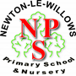
Week beginning Monday, 18th January 2021

Objective: Perform different styles of music.
Task 1
Below are the lyrics to A New Year Carol by Benjamin Britten. Listen carefully and label its structure. Use the table and the coloured bars below to help.
Instrumental intro 3 | Instrumental intro 2 | Verse 2 | Chorus | Chorus
Verse 1 | Chorus | Instrumental intro 1 | Verse 3

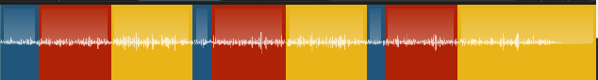

Benjamin Britten - A New Year Carol

Instrumental

Here we bring new water from the well so clear,
For to worship God with, this happy New Year.

Sing levy dew, sing levy dew, the water and the wine;
The seven bright gold wires and the bugles that do shine.

Instrumental

Sing reign of Fair Maid, with gold upon her toe,
Open you the West Door, and turn the Old Year go.

Sing levy dew, sing levy dew, the water and the wine;
The seven bright gold wires and the bugles that do shine.

Instrumental

Sing reign of Fair Maid, with gold upon her chin,
Open you the East Door, and let the New Year in.

Sing levy dew, sing levy dew, the water and the wine;
The seven bright gold wires and the bugles that do shine.

Structure:

Task 2: Have a look at the two songs below and see if you can identify the structure.
CAN'T STOP THE FEELING! (From DreamWorks Animation's "Trolls") (Official Video) - YouTube

Structure:

Trolls World Tour : We Will Rock You Rock n Trolls - YouTube

Structure:

