Date: wb 24th May Summer 1 2021
Objective: Content Domain 1B To retrieve and record information

Jam tarts NF (orange) 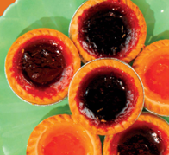

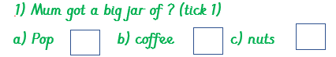

2) Which 2 items did she buy?
1. ----------------- 2.-----------------------

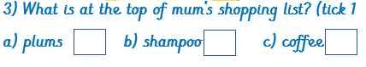

4) What did she buy a packet of?

_-----------------------------------------
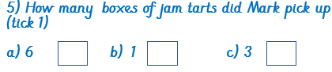

6) Do you think Mum was cross with Mark? Yes/No (circle 1) Why?/ Why not?

Because -----------------------------------------------

-------------------------------------------------------

